Process flow visualization
This section explains how the Machine Learning Model (ML model) fits in the current process. It outlines the planned workflow that clarifies how and where the ML model is applied in the decision-making process. It explains when each outcome is used, who is responsible for interpreting it, and how these insights contribute to more informed and deliberate choices.

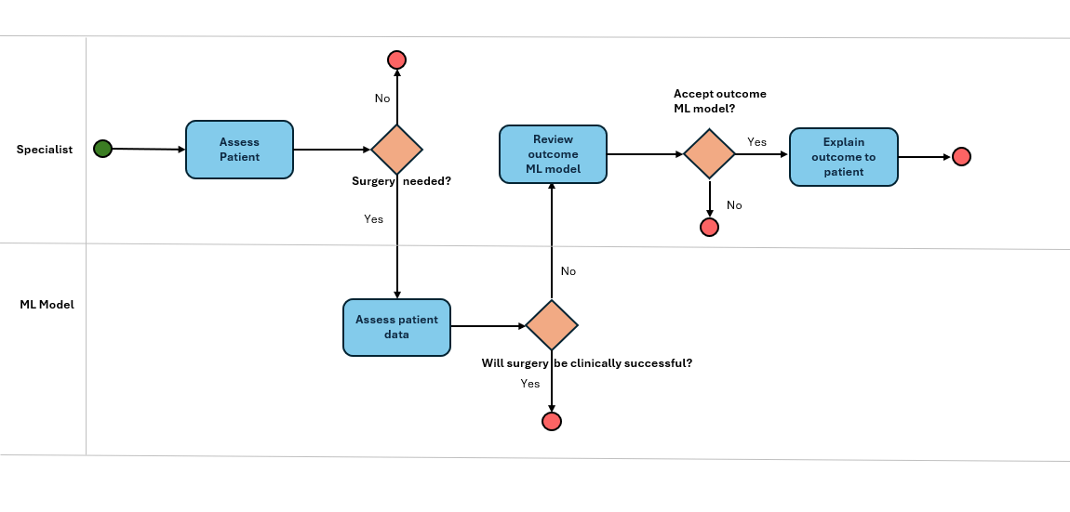
Assess patient: The specialist assesses whether the patient requires knee or hip replacement surgery. If the decision is no, the process ends. If yes, the next step involves the ML model.
Assess patient data: For patients recommended for surgery, the ML model analyses the patient’s data and predicts the likelihood of clinical success. The model either supports or does not support the specialist’s decision.
Review outcome ML model: If the model does not support the specialist’s decision, the specialist reviews the model’s explanation to understand the reasoning behind the prediction. This step is essential, as the specialist must fully understand why the model disagrees before deciding whether to accept or reject the model’s outcome.
Explain outcome to patient: When the specialist accepts the model’s outcome, they translate the model’s reasoning into patient-friendly language. This step relies on explainability, as the patient must understand the basis for the recommendation and how the model contributed to the decision.

